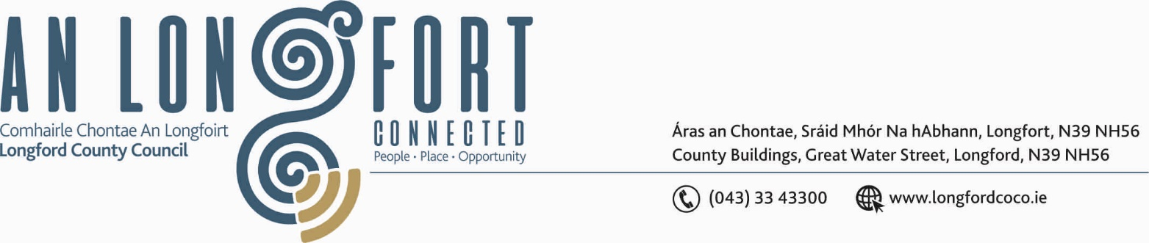

LONGFORD MUNICIPAL DISTRICT

21st March 2019.

To: Each Member of Longford Municipal District.

Dear Member,

You are requested to attend Meeting of Longford Municipal District to be held in the Council Chamber, Town Hall, Market Square, Longford, on Wednesday, 27th March 2019 at
4.00 p.m. to transact business, as set out on the Agenda hereunder.


Yours sincerely,

_______________
Anne Lee,
Meetings Administrator.

AGENDA
Prayer before meeting.

- Confirmation of Minutes of Longford Municipal District Meeting held on the
27th February 2019 – copy enclosed.

- Matters arising from Minutes.

- Management Report - to follow.

- To consider and approve Schedule of Longford Municipal District Works –
Report enclosed

- Consideration of applications for funding under the 2019 Community Grant Support
Scheme - list enclosed.

- Update on relocation of Salt Barn.

- Update on CCTV.

/2………

- Notices of Motions, submitted by Councillors, as listed hereunder -

Councillor Seamus Butler.

“That Longford Municipal District provides public lighting on Demesne Lane from the Battery Road to the entrance of Battery Court and provides speed ramps on the road in Battery Court from the entrance to the first corner.”

“That Longford Municipal District provides extra public lighting at Midara Gardens from the entrance to the next existing light on the left hand side.”

Councillor Joe Flaherty.

“That we take the required funding from the Development Levies to install public lighting at the Lamagh estate in Newtownforbes.”

“Carry out the preliminary traffic assessments ahead of the provision of traffic calming measures including speed tables in the Springlawn, St Emer's and Battery Court Estates.”

- Correspondence – enclosed.
(i) Letter dated 11th March 2019 received from St. Joseph’s Care Centre regarding the Famine Graveyard.

10. A.O.B.

